**CHAPTER 1**

**INTRODUCTION**

**1.1 GENERAL BACKGROUND**

OSNS have become integral part of our daily life and has profoundly changed the way we interact with each other, information sharing, appreciation and respect.Photo sharing is an attractive feature which popularizes Online Social Networks (OSNs). Unfortunately, it may leak users’ privacy if they are allowed to post, comment, and tag a photo freely. In this project , we attempt to address this issue and study the scenario when a user shares a photo containing individuals other than himself/herself (termed co-photo for short). However, once something, such as a photo, is posted online, it becomes a permanent record, which may be used for purposes we never expect. For example, a posted photo in a party may reveal a connection of a celebrity to a underworld. Because OSN users may be careless in posting content while the effect is so far-reaching, privacy protection over OSNs becomes an important issue. When more functions such as photo sharing and tagging are added, the situation becomes more complicated. For instance, nowadays we can share any photo as we like on OSNs, regardless of whether this photo contains other people (is a co-photo) or not[1].Currently there is no restriction with sharing of co-photos, on the contrary, social network service providers like Facebook are encouraging users to post co-photos and tag their friends in order to get more people involved. However, what if the co-owners of a photo are not willing to share this photo? Is it a privacy violation to share this co-photo without permission of the co-owners? Should the co-owners have some control over the co-photos?

To answer these questions, we need to elaborate on the privacy issues over OSNs. Traditionally, privacy is regarded as a state of social withdrawal. According to Altman’s privacy regulation theory . Privacy is a dialectic and dynamic boundary regulation process where privacy is not static but “a selective control of access to the self or to ones group.

To prevent possible privacy leakage of a photo, we design a mechanism to enable each individual in a photo be aware of the posting activity and participate in the decision making on the photo posting. For this purpose, we need an efficient facial recognition (FR) system that can recognize everyone in the photo. To do this we need a professional facial recognition (FR) system that cans recognize everyone in the photo. We are using Open CV face detection and CBIR (content based image retrieval) algorithm to train individual’s images and for face recognition. To get enough training sample is actually little difficult task, so FR engine may be unsuccessful to identify the faces of each individual in a group photo. To avoid this we are using an efficient CBIR algorithm. Once the faces are identified from the group photo then acceptance notifications are sending automatically to each identified persons within the close friend circle. The photo will be posted if all the people within the friend circle are accepting the notification; the photo will not be posted if any one of them rejects the notification. We expect that our proposed scheme would be very useful in protecting users’ privacy in photo/image sharing over online social networks[1].

**1.2 OBJECTIVE**

Photo giving out is one of the most well-liked features in online social networks such as Facebook. Lamentably, imprudent photograph posting may uncover security of people in a posted photograph. Main objective of the system is preventing the possible privacy leakage issue related to group photo uploading in social networks. To establish this every co-photo owners should participate in the decision making of photo posting. The system can solves the subject of posting group photos on a social network by sending a notification to co photo owners regarding their presence. If the entire co-photo owner then the s are accepting the notification, the group photo will be uploaded otherwise the photo will be rejected. We assume that each user *u* has a privacy policy *Pu*(*i*) and an exposure policy *Eu*(*i*) for a specific photo *i*. The privacy policy *Pu*(*i*) indicates the set of users who can access photo *x* and exposure policy *Eu*(*i*) indicates the set of users who can access *i* when user *u* is involved.[1] One of the main objectives is to get an efficient FR system for this project. If the photo co-owner is not login to the social network he or she is unable to see the notification and the group photo cannot be uploaded for long. To solve this issue it is possible to set a time limit, for example 2 days or 3days.If it is set 3 days time limit after that photo will be uploaded automatically. More over for the photo co-owners safety it is possible to send SMS regarding the photo uploading and time limit, so they can login and either accept or reject the notification, so this time limit setting and SMS notification can be do it as future enhancement . To do all of this we need a good FR system. . One of the main objectives is to get an efficient FR system for this project . This system is using CBIR (content based image retrieval) algorithm with K-mean clustering for training images and face recognition. [4].

**1.3 SCOPE**

A method is proposed to empower people conceivably in a photograph to give the consents before posting a co-photograph. A security protecting FR framework is outlined to distinguish people in a co -photograph. The proposed framework is highlighted with low calculation expense and classification of the preparation set. Hypothetical investigation and analyses were directed to show adequacy and proficiency of the proposed plan. We expect that our proposed plan be extremely helpful in ensuring clients' security in photograph/picture sharing over online informal communities. Then again, there dependably exist exchange off in the middle of protection and utility. We show that our system is superior to other possible approaches in terms of recognition ratio and efficiency. Expect that this proposed scheme would be very useful in protecting users’ privacy.

**1.4 SCHEME OF PROJECT WORK**

This thesis is organized in such a way that, Chapter 1 includes the introduction section which explains Introduction including General Background, Objective, Scope, Scheme of project work etc…

Chapter 2 gives a brief survey done on control of photo sharing on online social networks

Chapter 3 gives the problem definition.

Chapter 4 deals with the detailed study of the Proposed System.

Chapter 5 deals with task setup and implementation.

Chapter 6 deals with the results and discussions

Chapter 7 gives the Conclusions and future directions.

**CHAPTER 2**

**LITERATURE SURVEY**

Photo sharing is probably the most popular feature in online social networks such as Facebook. Unfortunately, careless photo posting may reveal privacy of individuals in a posted photo. The things become more difficult when it is added much functions like photo uploading and tagging. For instance, these days we can contribute to any picture as we like on OSNs, in spite of whether this photograph contains other populace (is a co-photo) or not.This section first two papers discuss various security issues and the available prevention methods related to group photo uploading , and the next four papers discuss about the face recognition system and various CBIR algorithms used for the face recognition system because for the efficient working of this system a good FR system is needed.

**2.1 PRIVACY ATTACKS IN SOCIAL MEDIA USING PHOTO TAGGING NETWORKS: A CASE STUDY WITH FACEBOOK**

Social-networking users unknowingly reveal certain kinds of personal information that malicious attackers could profit from to perpetrate significant privacy breaches. This section quantitatively demonstrates how the simple act of tagging pictures on the social-networking site of Facebook could reveal private user attributes that are extremely sensitive. Our results suggest that photo tags can be used to help predicting some, but not all, of the analyzed attributes. We believe our analysis make users aware of significant breaches of their privacy and could inform the design of new privacy-preserving ways of tagging pictures on social-networking sites.

Photo tagging is a popular feature of many social network sites that allows users to annotate uploaded images with those who are in them, explicitly linking the photo to each person’s profile. In this document, it is inspected confidentiality concerns and mechanisms regarding this tagged photograph... Using a focal point of group, we explored the requirements and concerns of users, follow-on in a set of design considerations for tagged photograph confidentiality[2],[13].

Now Facebook added the new security to prevent the privacy leakage issue due to photo tagging, people can set “review the tag before appearing the time line option “.but still people can share the photo because somebody is uploading the photo first without taking the co- photo owner’s permission so even the review tag options is available, it is not preventing co-photo owner’s privacy.

**2.2 MULTI-PARTY PRIVACY RISKS IN SOCIAL NETWORKS**

Most social media users consistently criticize mainstream social media for providing very complex privacy controls. These are often too difficult to understand, require time-consuming manual configuration, and do not allow for appropriate privacy management. Users are required to set many privacy controls . This makes most users unable to cope with the complexity of privacy management in social media, which has led to numerous incidents in which people have lost their jobs, have been cyber bullied, or have lost court cases due to the inappropriate communication of personal information through social media. Empirical evidence shows that this significantly discourages users to either join social media or to show high engagement when they join in terms of how much they participate in social media sites, e.g., the amount of photos they upload. In this section, we examine how the lack of joint privacy controls over content can inadvertently reveal sensitive information about a user including preferences, relationships, conversations, and photos

This slow erosion of personal privacy can be prevented by the adoption of multi-party privacy controls. The current lack of multi-party privacy results in scattered references to users throughout social networks that can be collected by adversaries who have the resources, sophistication, and motivation to glean as much information from social networks as possible[9][10]. Facebook's privacy model can be adapted to enforce multi-party privacy which is shown in below figure.

. Here user can decide how many want to give the access permission to share the group photo, so user can select a group of people before uploading a group photo, those are allow to access and share the group photo or user can select certain people and deny their access and share permission of a group photo. This is also one of the prevention method of privacy leakage issue but still a single conflict may pose a minimal risk to privacy and still it is not preserving the co-photo owners privacy.

**2.3 FACE RECOGNITION FOR IMPROVED FACE ANNOTATION IN PERSONAL PHOTO COLLECTIONS SHARED ON ONLINE SOCIAL NETWORKS.**

Using face annotation for effective management of personal photos in online social networks (OSNs) is currently of considerable practical interest. In this paper, we propose a novel collaborative face recognition (FR) framework, improving the accuracy of face annotation by effectively making use of multiple FR engines available in an OSN. In particular, our collaborative FR framework consists of two major parts: selection of FR engines and merging (or fusion) of multiple FR results. The selection of FR engines aims at determining a set of personalized FR engines that are suitable for recognizing query face images belonging to a particular member of the OSN. For this purpose, we exploit both social network context in an OSN and social context in personal photo collections. In addition, to take advantage of the availability of multiple FR results retrieved from the selected FR engines, we devise two effective solutions for merging FR results, adopting traditional techniques for combining multiple classifier results. Experiments were conducted using 547,991 personal photos collected from an existing OSN [3].

Our results demonstrate that the proposed collaborative FR method is able to significantly improve the accuracy of face annotation, compared to conventional FR approaches that only make use of a single FR engine. We demonstrate that our collaborative FR framework has a low computational cost and comes with a design that is suited for deployment in a decentralized OSN. Accuracy is high in collaborative FR system but it is time consuming and 100% face recognition is not ensure here.

2.4 **COLOR AND TEXTURE FEATURES FOR CONTENT BASED IMAGE RETRIEVAL**

CBIR, Content Based Image Retrieval has been an important area of research in the last few

decades. A retrieval mechanism using color and texture is being proposed here. Depending on the characteristic of the image texture, it can be represented by multi wavelet transform. The color correlogram in the RGB color space is chosen as the color feature. The main motivation of this system is to use the Multi Wavelet decomposition scheme and color correlogram, which yield improved retrieval performance. Through the combination of Multi wavelet decomposition and color correlogram we can increase the number of features, which in turn improves the retrieval accuracy. To support the efficient and fast retrieval of similar images from image databases, feature extraction plays an important role. The technique used for comparing images plays the fundamental ingredient of content based image retrieval.

**2.4.1 Color Correlogram**

A new feature for color retrieval is the color correlogram.This feature only captures spatial

correlation between identical colors, that is, it characterized how the spatial correlation of pairs of color changes with distance in an image.

**2.4.2 Multi Wavelet Transform**

MultiWavelets are defined using several wavelets with several scaling functions. The base

features for this transform include compact support, Orthogonality, symmetry, and high order

approximation . A scalar wavelet cannot possess all these properties together at the same time, whereas a multiwavelet can can simultaneously provide perfect representation while preserving length, good performance at the boundaries , and a high order of approximation . Therefore, Multiwavelets offers superior performance and high degree of freedom for image processing applications, compared with scalar wavelets [11].

Steps:

1. Texture Feature Extraction

(a) Convert all database images into gray images.

(b) Decompose each image in the Multi wavelet domain.

(c) Compute the standard deviation σ k on each sub-band of the Multi Wavelet decomposed

image.

(d) The resulting SD vector is -

*f* = [ σ 1, σ2, σ 3, *……,* σ*k* ]

2. Color Feature Extraction

(a) Load the image.

(b) Separate the R, G, and B spaces from the image.

(c) Quantize the each color space into 32 levels .

(d)Apply the correlogram in 0 0 , 45 0 , 90 0 , and 135 0 on each color space.

(e) Construct the feature vector by using correlogram.

3. Combined Feature

Form the combined feature vector by concatenating the color feature and texture feature.

4. Apply query image and calculate the combined feature vector as given in steps A to B.

5. Calculate the similarity using Euclidean distance.

distance.JPG (2.4.1)

6.Retrieve all relevant images to query image based on minimum “Euclidean distance”.

The main advantage of wavelet decomposition is that it yields a large number of sub bands. which in turn improves the retrieval accuracy. A major disadvantage of this technique is its limitation in feature set.

**2.5 SEMANTIC IMAGE RETRIEVAL BY COMBINING COLOR,TEXTURE AND SHAPE FEATURES**

The problem of retrieving desired image from huge database is a major problem. The subjectivity of human perception and the rich contents of the images further increase the complexity of the problem. To overcome this problem, a new query-by-example technique[17] using multiple color, texture and shape features is being proposed here.The accuracy of the image retrieval system is difficult to be defined as different people have

different notions regarding similarity of an image. Hence, the system must developed such that it takes into account the different views from different users.Here, the system uses a two phase methodology. In the first phase, feature database is created. In the second phase images related to the query image desired the by the user is retrieved. For image retrieval, the database is filtered very coarsely. It is done using hue histogram technique.

Feature matching is then done on this reduced dataset. At the end of this step, for each feature, a set of images are obtained. Finally, we retrieve the images by combining all the features which results in a set of images which are semantically more similar to the query image.

The main advantage of this system is that it reduces the data set and also all similar images of the related feature are retrieved.Major limitation of the system is that both similarity measurement and image retrieval are performed twice, so that it increases calculation**.**

**2.6 CBIR BASED IMAGE RETRIEVAL USING MODIFIED HAAR WAVELET TRANSFORM AND K MEANS CLUSTERING**

**2.6.1 Content based image retrieval**

To retrieve any image, we have to search for it among the database using some search engine. Then, this search engine will retrieve many of images related to the searched one. The main problem encounters user here is the difficulty of locating his relevant image in this large and varied collection of resulted images. This problem referred to as *image retrieval problem*

The earlier approach for image retrieval is *text-based*, in which images are indexed using keywords, subject headings, or classification codes which in turn are used as retrieval keys during search and retrieval [4][5][6]. Unfortunately, for the large database the difficulties faced by text-based retrieval became more and more severe and the process becomes very laborious and time consuming task.

To overcome these problems and others, the image contents, features of the image, like color, texture and shape that are automatically extracted from the images themselves have been used for image retrieval. This method is called *content-based image retrieval* (CBIR) [5]. CBIR enables the elimination of the difficulties that exist in traditional text-based query for large image database and then the system will provide better indexing and return more accurate results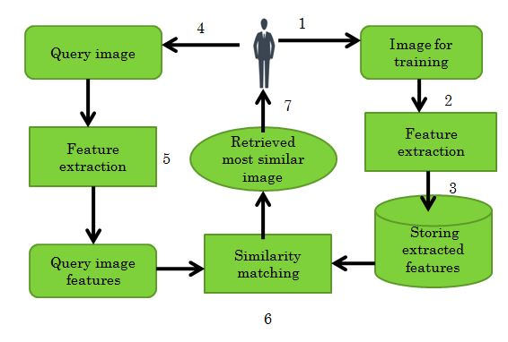

Fig. 2.6.1 Architecture of CBIR system ( Ahmed K. Mikhraq ,2013)

"Content-based" means that the search will analyze the actual contents of the image rather than the metadata such as keywords, tags, and/or descriptions associated with the image. The term 'content' in this context might refer to colors, shapes, textures, or any other information that can be derived from the image itself

**2.6.2 CBIR Algorithm:**

Purpose: Retrieving most similar image to input image.

Input: Query image.

Output: Most similar image to the input image.

Procedure:

{

Step 1: The input image.

Step 2: Extract the feature vector for the input image

Step 3: Calculate the weighted features vectors for the input image.

Step 4: Calculate the distance between the input image and the centroid

of each K-mean cluster and find the smallest distance.

Step 5: Calculate the distance between the input image and the images

in the cluster that has the smallest distance with the input image.

Step6: Retrieve the image that is more similar to the input image.

}

The main unit of CBIR is an image retrieval technique that used to retrieve from the database the most similar images to the query image [9]. A typical content-based retrieval system is divided into *off-line feature extraction* and *online image retrieval*. In off-line stage, the system automatically extracts visual attributes at either a low-level (such as color, texture, and shape) or at a high-level (such as a color histogram), or both for each image in the database based on its pixel values and stores them in a different database within the system called a feature database [8]. The feature data (also known as image signature) for each of the visual attributes of each image is very much smaller in size compared to the image data. . A Haar Wavelet transform decomposes an image into two components: average and difference.Each color in the image can be represented by considering the pixels as a point in space and from this matrices for each Red, Green and Blue components of RGB are constructed. Once decomposition over calculate feature vector based on F-norm theory storing the values to cluster files for future use.

**2.6.3 K-Means for Database Clustering**

The time of image retrieval in almost all CBIR systems depends in a large degree on the number of images in the database. Many existing systems attempt to compare the query image with every target image in the database to find the top matching images, resulting in an essentially linear search, which is highly computationally inefficient when the database is large. However, it is a benefit to use all images in the database for similarity matching, so that the results will be good enough. To overcome this problem, image clustering or categorization has often been treated as a preprocessing step to speed-up image retrieval in large databases and to improve the accuracy so that when a query is received, only a part of the database needs to be searched, while a large portion of the database may be eliminated in the search. This certainly saves significant query processing time without compromising the retrieval precision. Clustering algorithms are used as a preprocessing step, performed offline, to cluster the database into *N* different categories [12] and each feature vector, along with its associated class number, is recorded in the database files.

The basic step of k-means clustering is simple. In the beginning, determine number of cluster K and assume the centroid or center of these clusters. We can take any random objects as the initial centroids or the first K objects can also serve as the initial centroids. Then the K means algorithm will do the three steps below until convergence

Clustering is very efficient and powerful technology to handle large data sets. It assists faster image retrieval and also allows the search for most relevant images in large image database [16]. K-means is a clustering method which is known for its efficiency in producing accurate results in image retrieval. By using k-means user can select the closer group of image so that they get fast result.

Finally, query image is the image the user is interested in and wants to find similar images from the image database. The feature vector for the query image is extracted and is now compared with the image clusters. Based on minimum Euclidean distance, the target image cluster closest to the query image is retrieved from the database.

In the proposed system, we use k-means algorithm to classify the feature vectors of the input images. We select the k-means algorithm because it is suitable to cluster large amount of data. Each feature vector is treated as an object having a location in space. The cluster generates in which objects within this cluster are close to each other and far from objects in other clusters as possible. Selecting the distance measure is an important step in clustering. The distance measure determines the similarity of two images.

A cluster is a group of objects that are similar to each other within the same group and are dissimilar to the objects in other groups. Clustering has been widely used in different applications, including pattern recognition, data analysis, machine learning, and image processing. K-means is one of the simplest clustering algorithms. In k-means algorithm, the clustering results are measured by the sum of within-cluster distances between every vector and its cluster centroid. This criterion ensures that the clusters generated are tight. K-means algorithm takes k, the number of clusters to be generated, as the input parameter and partitions a set of N objects into k clusters so that the resulting intra-cluster similarity is high but the inter-cluster similarity is low. If the number of clusters is not specified, a simple method is done. The algorithm initializes the number of clusters to a certain number less than the total number of the dataset. The algorithm increases that number gradually until the average distance between a vector and its cluster centroid is below a given threshold [6].

The k-means algorithm works as the following. The number of clusters, *k*, is entered as an input parameter. The algorithm randomly selects *k* of the objects, each of which initially represents a cluster centroid. The centroid for each cluster is a point to which the sum of distances from all objects in that cluster is minimized. For each of the remaining objects, an object is assigned to the cluster to which it is most similar.

**CHAPTER 3**

**PROBLEM DEFINISION**

In a typical CBIR system, low- level visual image features that is colour, texture, and shape are automatically extracted for image descriptions and indexing purposes. To search for desirable images, a user presents an image as an example of similarity, and the system returns a set of similar images based on the extracted features The main issue with CBIR system is the time of image retrieval in almost all CBIR systems depends in a large degree on the number of images in the database.. Two main issues with CBIR systems are efficiency and accuracy. Hence, an effective CBIR system needs to have an efficient search mechanism and also accurate set of features. Out of all the mechanisms used in CBIR, k-means clustering is found to have better efficiency and accuracy. "Content-based" means that the search will analyze the actual contents of the image rather than the metadata such as keywords, tags, and/or descriptions associated with the image. The term 'content' refer to colours, shapes, textures, or any other information that can be derived from the image itself. CBIR is desirable because most web based image search engines rely purely on metadata and this produces a lot of garbage in the results. Also having humans manually enter keywords for images in a large database can be inefficient, expensive and may not capture every keyword that describes the image. Thus system that can filter images based on their content would provide better indexing and return more accurate results. Again the performance of the CBIR system is improved by using K-Means clustering technique . .If we are using CBIR to train individual’s images and for face recognition in our proposed system. To get enough training sample is actually little difficult task, so FR engine may be unsuccessful to identify the faces of each individual in a group photo.FR engine could be trained to recognize social friends (people in social circle) but to get enough training sample is a difficult task.To get efficient result CBIR demands more training samples (photos of each specific person), but online photo resources are often insufficient, also with varying poses and facial expressions CBIR system may fail to recognize the faces of each individual in a group photo. More demanding privacy setting may limit the number of the photos publicly available to train the FR system..Another major issue we are facing is large number of users are absent for us to carry out the network-wide evaluation. We simulate a real-life social network with the small-world network.

**CHAPTER 4**

**METHODOLOGY**

To curb the privacy leakage, we proposed to enable individuals potentially in a photo to give the permissions before posting a co-photo. We designed a privacy-preserving Content based image retrieval FR system to identify individuals in a co-photo. The proposed system is featured with low computation cost and confidentiality of the training set.. The proposed system added time limit for notification acceptance, and SMS notification to inform the co-photo owner about the time limit for notification. We expect that our proposed scheme be very useful in protecting users’ privacy in photo/image sharing over online social networks.

**4.1 PROOSED SYSTEM ARCHITECTURE**

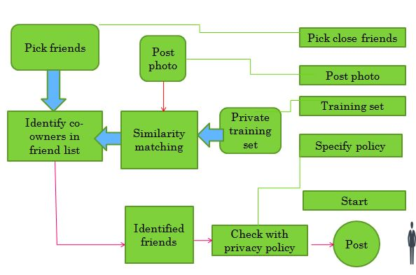

Fig.4.1*:*  Proposed System Architecture

**4.1.1Start**

User can register to Online Social Network by entering the details like name, DOB, gender, Email, mobile number, username, password etc. Once registered successfully user can login to his/her account. User or admin can login to this system if they have a valid user id and password. Admin can login with a valid password, once login admin can view the user details; main function of admin is to train the user image

**4.1.2 Specify policy**

We assume that each user u has a privacy policy Pu(i) and a exposure policy Eu(i) for a specific photo i. The privacy policy Pu(i) indicates the set of users who can access photo i

.In our project we set two options ,one is view public and net is view my friends.If a user is selectiong public option ,once photo is uploaded that photo will be shown publically ,if he/ she is setting only my friends option then once the photo uploaded photo will be available in the time line of his/her friends home page. and exposure policy Eu(i) indicates the set of users who can access i when user u is involved.In our project we limited this within the close friend list. According to our scheme, this friend list should be intersection of owner’s privacy policy and co-photo owners’ exposure policies. At present, when the push button “Post Photo” is pressed, co-owners of i are identified, and then notifications along with i are sending to the co-owners within the close friend list to request permissions. If they all agree to post i, i will be shared on the owner’s page like a normal photo. In this sense, users could specify their privacy policy but their exposure policies are depends the set of users who can access i when user u is involved

**4.1.3 Training**

A log in/out button could be used for log in/out with our socialnetwork site. After login in, the profile picture will be shown. , we need an efficient content based image retrieval facial recognition (FR) system that can used to train users images. We are using Haar cascade classifier for face detection and CBIR algorithm to train individual’s images and for face recognition. FR engine could be trained to recognize social friends (people in social circle) but to get enough training sample is a difficult task. FR engine with advanced recognition ratio demands more training samples. In the training phase, both decomposition and feature extraction takes place. Haar Wavelet Transform is used for calculating the feature vectors, weighted feature vector represented as weight function *w().* Then k-means clustering algorithm is used for clustering the images based on their feature vectors , considering the minimum Euclidean distance. The basic idea is to transfer an image into matrix in which eachelement of the matrix represents a pixel in the image. A Haar Wavelet transform decomposes an image into two components: average and difference.Each color in the image can be represented by considering the pixels as a point in space and from this matrices for each Red, Green and Blue components of RGB are constructed. This is then decomposed into four sub-matrices through row and column transformations[Appendice A].

**(i) The formula for calculating average and difference**

*avg* =( *fn*+ *fn*+1)/√2 , where n=1,2,3…...n/2 ( 4.1)

And difference at the same level is given by

*diff* =(*fn*-*fn*+1)/√2 , where n=1,2,3 .....n/2 (4.2)

**(ii) To calculate the Haar transform of an array of *n* samples:**

1. Find the average of each pair of samples. (*n*/2 averages)

2. Find the difference between each average and the samples it was calculated from. (*n*/2 differences)

3. Fill the first half of the array with averages

4. Fill the second half of the array with differences.

5. Repeat the process on the first half of the array. While doing this the array size should be power of two.

This steps are repeated for both row and column. Once the process is completed, the matrix gets decomposed into four sub-matrices each of dimension (number of rows/2) x (number of

columns/2) and is called A, H, V and D respectively. A (approximation area) contains

information about the analyzed image’s global properties, H (horizontal area) contains

information about vertical lines hidden in the image, V (vertical area) contains information about the horizontal lines hidden in the image and D (diagonal area) contains information about the diagonal details hidden in the image.

**(iii)The advantages of Haar Wavelet transform:**

1. Best performance in terms of computation time

2. Computation speed is high

3. Simplicity

4. HWT is efficient compression method.

2

deviation of energy distribution ( F-norm) of each sub-band at each level.

Given a square matrix A and A i is the submatrix from it, then F-norm is given by-

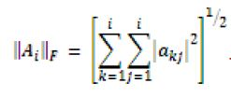

(4.3)

Mean and StandardDeviation(SD) and variance can be calculated usig

Mean( µ)= ∑F-norm/no of columns of F-norm (4.4)

Standard Deviation(σ )= (4.5)

Variance = σ2 (4.6)

**(iv) K-Mean Algorithm.**

The basic step of k-means clustering is simple. In the beginning, determine number of cluster K and assume the centroid or center of these clusters. We can take any random objects as the initial centroids or the first K objects can also serve as the initial centroids. Then the K

means algorithm will do the three steps below until convergence

Algorithm for K Means Clustering:

1. Determine the initial centroid coordinate

2. Determine the distance of each object to the centroid

3. Group the object based on minimum Euclidean distance (find the closest centroid)

**4.1.4 Pick friend**

User can search through this social networking site to get friends ,there is an invite friend option is there to find friends, user needs to set “close friends” among their Social Network friends either by sending friend request or accepting others friend request. When a person try to upload a group photo, FR system identify all co-photo owners from this close friends group.

**4.1.5 Photo Uploading**

Once a user is logging in to his/her account, he/she can use the photo posting feature of OSN.

In this phase, when an image is uploaded,all the faces in the images is detected by open CV face detection using Haar Cascades[Appendice B]. Once each faces are croped from the given image then its feature vectors are computed using the same procedure which we have done in training image. this vector is compared to the vectors of images in the training set using Euclidean distance.

. The classification of the most similar images would be returned as the class of the newly uploaded image, similarity function represented *sim()* , then checking the recognized faces are in the friend list of uploader. When posting a group photos on online social network an automatic acceptance notification is sending to the co photo owners in the close friend circle informing their presence in that group photo, so each co-photo owners are getting the chance to view the photo where they are in before the up loader post the photo and any one of them press reject button nobody can upload that photo, if all are pressing acceptance button, then only the photo will be posted. More over we set a time limit for the notification acceptance, the reason behind this is if co-photo owners are not login to this system for long, the one who trying to upload a photograph will be a failure, if the time limit is exceeded the photo will be uploaded automatically. Sometimes the co-photo owners are unable to login to this account within the time limit, so to avoid this issue we can add SMS notification option to inform each co-photo owners about the photo uploading and time limit, so it is useful them to login to the system and either accept or reject the notification. It can be added in future enhancement.

It is used to prevent possible privacy leakage of a photo, this mechanism is enabled each person in a photograph be aware of the posting the photograph and actively participate in the decision making on the photograph posting

In this Project there are mainly two parts user and admin. Use case diagram and collaborative diagrams of admin is given below.

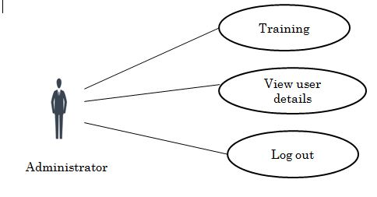

Fig.4.2 Use case diagram of Admin

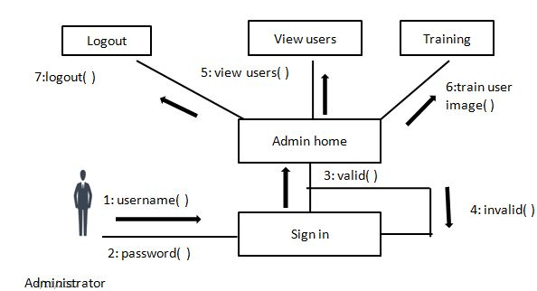

Fig.4.3. Collaborative diagram of Admin

Admin can login with a valid password, once login admin can view the user detals like username, profile picture, email id, mobile phone number, moreover admin can do the performance analysis. Performance analysis is done based on time taken (mille seconds)to train an image, face detection and face recognition. It can be displayed using a bar chart. main function of admin is to train the user image and saving values corresponding to each image in a cluster file for later search process.

This project is based on social networking platform, so most of the operations are done by user. Use case diagram and collaborative diagrams of user is given below.

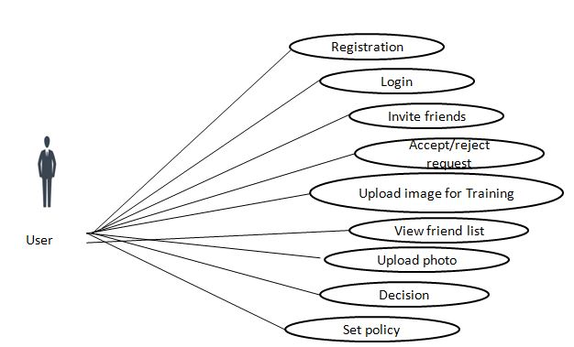

Fig.4.4. Use case diagram of User

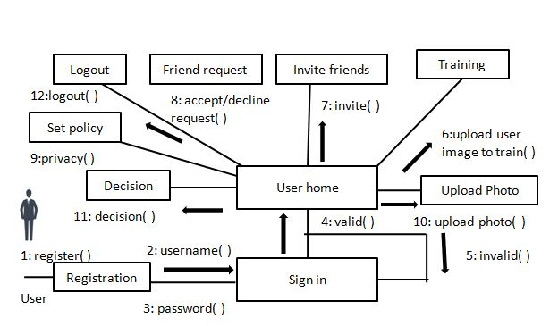

Fig.4.5.Collaborative diagram of User

In this system an individual can create an account using “new registration option”, then user can login with a valid username and password, user can select his/ her image for taining purpose, once image selected admin will do the training process. User can choose friends by using invite friend option. Policy setting is an important part in this project, if user is selecting the notification checkbox then only he/she will get the notification whenever somebody is trying to upload his / her photo. Photo uploading is the main part done by user, here face detection and recognition is take part.

**4.2 PROPOSED ALGORITHM**

Purpose: Retrieving most similar images to input image.

Input: Image of a group photo

Output: Most similar images to the input image.

Procedure:

Step 1: The input image, which containing one or more faces.

Step 2: Detecting all faces in the image.

Step 3: Extract the feature vector for the input image

Step 4: Calculate the weighted features vector for the input image.

Step 5: Calculate the distance between the input image and the images in the cluster

that has the smallest distance with the input image.

Step 6: Retrieve the images that is more similar to the input image. Send acceptance

notification to co -photo owners within the close circle.

**CHAPTER 6**

**TASK SETUP AND IMPLEMENTATION**

* 1. **MODULES**

6.1.1Admin

* Train image

1. Face detection
2. Image decomposition
3. Feature extraction
4. Clustering
   * 1. User

* Photo uploading

1. Face detection
2. Face recognition and notification sending

**6.2 REQUIREMENTS**

**Table 6.2.1 Software Requirement**

|  |  |
| --- | --- |
| Operating System | Windows |
| Language | Java |
| IDE | NetBeans |
| Back End | MySQL |

**Table 6.2.2 Hardware Requirements**

|  |  |
| --- | --- |
| Hardware : Pentium Dual Core |  |
| Speed | 2.80 GHz |
| RAM | 2GB |
| Hard Disk | 20 GB |
| KeyBoard | Standard Windows Keyboard |
| Mouse | Two or Three Button Mouse |
| Monitor | SVGA |

**CHAPTER 7**

**RESULT AND DISCUSSION**

**7.1 RESULT**

Careless photo posting may reveal privacy of individual in a posted photo. This result enables individuals potentially in a photo to give the permissions before posting a co-photo. We designed a privacy-preserving FR system to identify individuals in a co-photo. The proposed system is featured with low computation cost and confidentiality of the training set. Theoretical analysis and experiments were conducted to show effectiveness and efficiency of the work. To post a photo user need to create an account in social network .the result of successful user login output is shown below

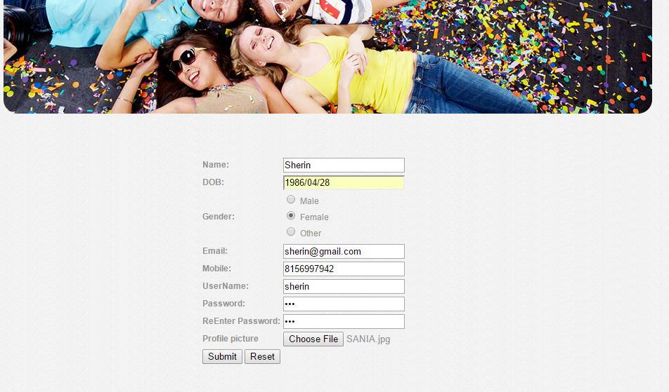

Fig.7.1 User registration

If the registration done successfully user can login to his/her account to explore the features of onine social networking



Fig.7.2 User log in

Once user login to his /her account he/she can select an image of his/ her to train the image

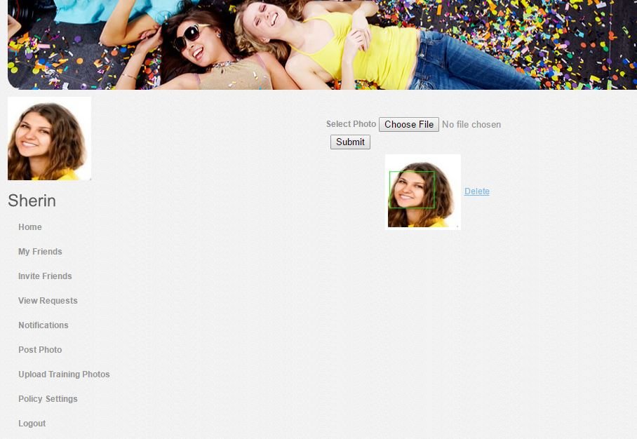

Fig.7.3 Upload image for training

Once user select an image and upload it for training, then the notification is going to administrator. Administrator can now train the image.



Fig.7.4 Admin train the image

User is able to send a friend request and accept friend request

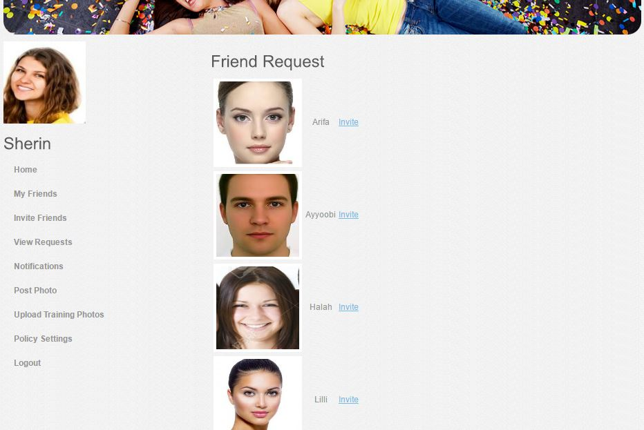

Fig.7.5 Invite friends

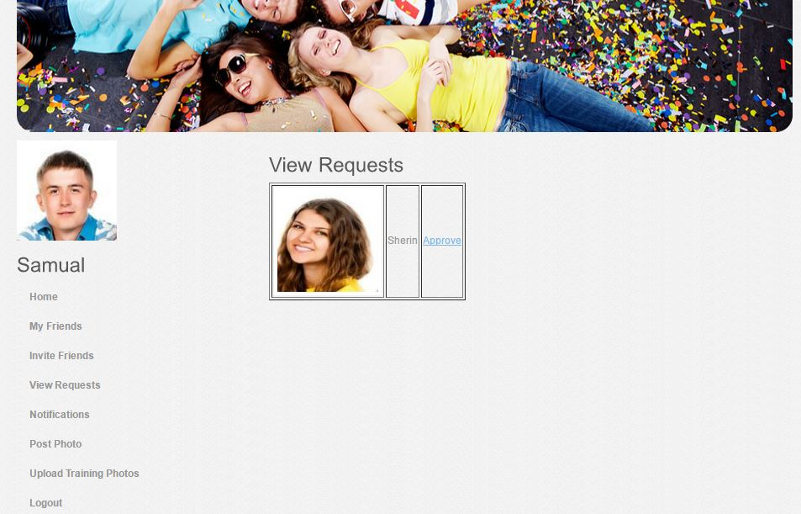

Fig.7.6 View friend request

User is able to view his/her friend list

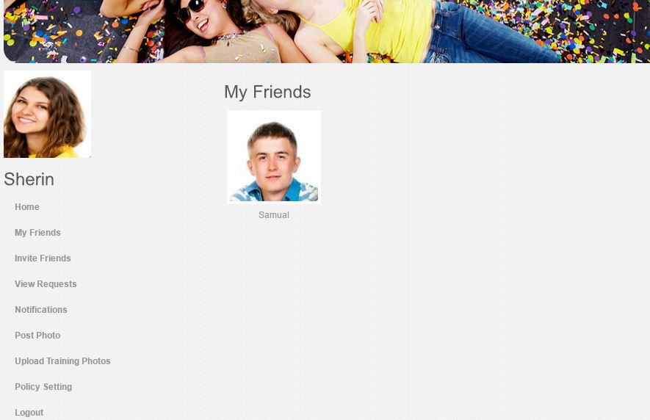

Fig.7.7 Friend list

User can browse a photo from gallery and upload it by using post photo option. Face detection module will be activated and cropping all the individuals face from the photo which is being uploading.

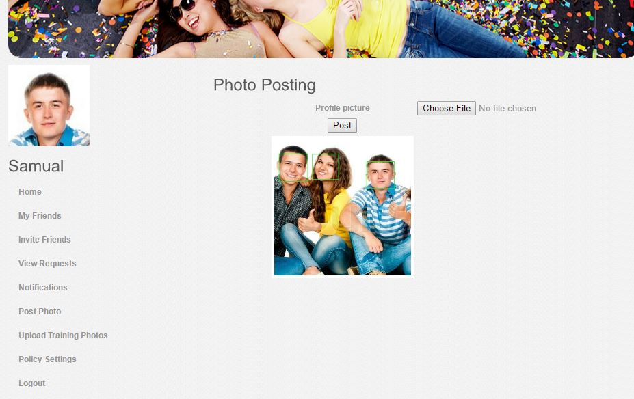

Fig.7.8 Face Detection

When a user try to upload a group photo all the individuals faces will be detected and FR system that cans recognize everyone in the photo. We are using Eigen face method for face detection and artificial neural network back propagation algorithm to train individual’s images and for face regonition FR system will identify each individual by comparing their face with trained set of images .if a match is found sending a notification to co photo owners within close friend circle informing their presence.



Fig.7.9 Acceptance Notification

If all the notification are accepted by co-photo owners then the group photo will be uploaded and displayed on the time line page of Social networking site.

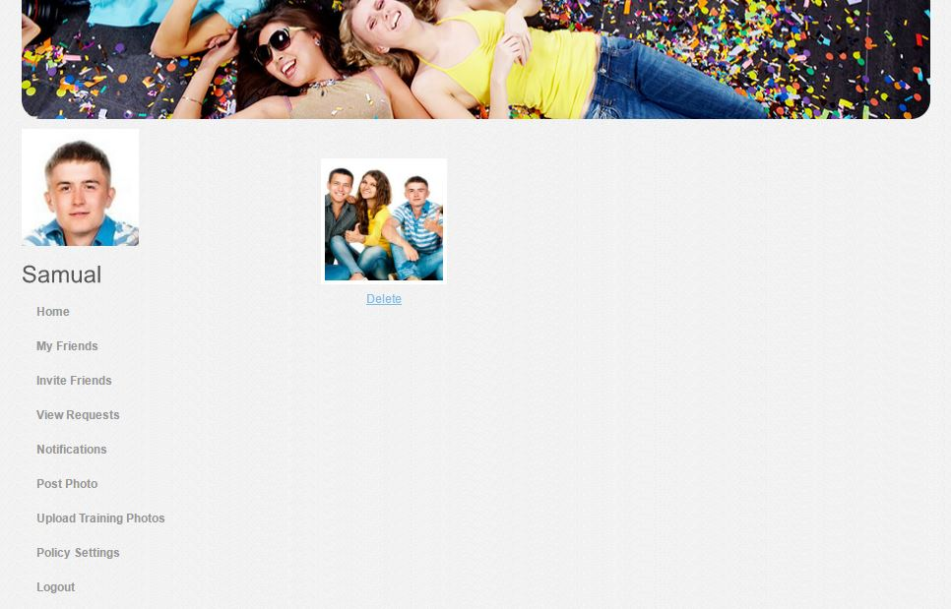

Fig.7.10 Photo posted on time line of Social Networking site

**7.2 DISCUSSION**

Control of photo sharing on online social network project work has completed successfully. Various test is conducted during the code generation phase itself. All the errors were rectified at the moment of its discovery. Attention is diverted to individual modules, independently to one another to locate errors. Registration ,login, photo uploading, privacy policy settings, training individuals images, send and accept friend request ,photo detection, face recognition and notification acceptance modules tested independently ,this has enabled the detection of errors in coding and logic. Finally all these modules are integrated in a master page and tested successfully. Careless photo posting may reveal privacy of individual in a posted photo. This result enables individuals potentially in a photo to give the permissions before posting a co-photo. We designed a privacy-preserving FR system to identify individuals in a co-photo. The proposed system is featured with low computation cost and confidentiality of the training set. Theoretical analysis and experiments were conducted to show effectiveness and efficiency of the work. I expect that scheme be very useful in protecting users’ privacy in photo/image sharing over online social networks.

**7.3 PERFORMANCE ANALYSIS**

This section, analyse the overall performance of the proposed system by computing the

performance score for each module in the system. The modules used for the performance analysis are image training, face detection,­­ face recognition. Then plot the performance graph with time in milliseconds . The performance analysis graph are shown in Fig.3.1

8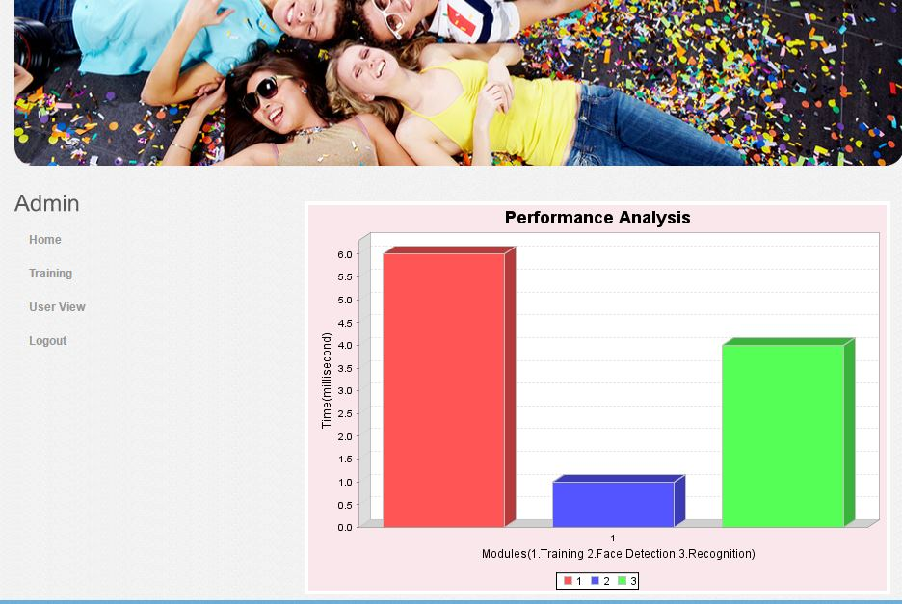­

Fig.7.3.1 Performance analysis

**CHAPTER 9**

**CONCLUSION AND FUTURE ENHANCEMENT**

Photo sharing is one of the most popular features in online social networks such as Facebook. Lamentably, imprudent photograph posting may uncover security of people in a posted photograph. To control the security spillage, we proposed to empower people possibly in a photograph to give the consents before posting a co-photograph. We planned a security safeguarding FR framework to recognize people in a co-photograph. The proposed framework is highlighted with low calculation expense and privacy of the preparation set. Hypothetical examination and trials were directed to show adequacy and effectiveness of the proposed plan. We expect that our proposed plan be exceptionally helpful in ensuring clients' protection in photograph/picture sharing over online informal organizations. Then again, there dependably exist exchange off in the middle of protection and utility. For instance, in our application, the co-photograph must be post with consent of all the co-proprietors. Idleness presented in this procedure will enormously affect client experience of OSNs. Moreover, neighborhood FR preparing will deplete battery rapidly. Our future work could be the way to move the proposed preparing plans to individual mists like Dropbox and/or icloud.

REFERENCES

[1] **Kaihe Xu, Yuanxiong Guo, Linke Guo, Yuguang Fang**,and **Xiaolin Li**,” My

Privacy My Decision: Control of Photo Sharing on Online Social Networks”. *IEEE*

*Transactions on Dependable and Secure Computing*  Volume: PP, [Issue: 99](http://ieeexplore.ieee.org/xpl/tocresult.jsp?isnumber=4358699) 10June 2015.

[2]**A.Besmer** and **H. Richter** **Lipford** (2015) “Moving beyond untagging:photo privacy in a

tagged world. In proceedings of the SIGCHI”*Conference on Human Factors in computing*

*Systems*, 10, 1563–1572, New York,N USA. ACM

[3] **J. Y. Choi, W. De Neve, K. Plataniotis**, and **Y.-M.Ro**” Collaborative face recogn-

ition for improved face annotation in personal photo collections shared on online social

networks”, *IEEE Transactions on Multimedia*, 13(1):14 .28. 011

[4] **S. D. P.W. Huang**, (2003) “Image retrieval by texture similarity,” Pattern Recognition,

36, 665- 679

[5] **Y. C. C.H. Lin, R.T. Chen** (2009) “A smart content-based image retrieval system based

on color and texture feature,” *Image Vis. Compute*., 27(6), 658-665

[6] **K.-K. M. Ju Han**(2007) “Rotation-invariant and scale-invariant gabor features for texture

image retrieval,” *Image and Vision Computing*, 25, 1474-1481

[7] **B. C. M. Kokare,** and  **P.K. Biswas**,(2007) “Texture image retrieval using rotated wave-

let filters,” *Pattern Recognition* , 28, 1240-1249

[ 8] **A. J. K. Iqbal,M O. Odetayo**,(2012) “Content-based image retrieval approach for bio-

metric security using colour, texture and shape features controlled by fuzzyheuristics,

*“Journal ofcomputer and System Sciences,*78,1258-1277.

[9] **Jose.M.Such** and **Natalia Criado**,” Resolving Multi-Party Privacy Conflicts in

Social Media” *I*[*EEE Transactions on Knowledge and Data Engineering*](http://ieeexplore.ieee.org/xpl/RecentIssue.jsp?punumber=69) . Volume:8,

[Issue: 7](http://ieeexplore.ieee.org/xpl/tocresult.jsp?isnumber=7484370),6,June,2016

[10] **K. Thomas, C. Grier** and **D. M. Nicol**,(2010) "Unfriendly: Multi-party privacy risks in social networks", Proc. 10th Int. Symp. Privacy Enhancing Technol,4*,*236-252.

**[11] P.V.N Reddy, K.Satya Prasad (** 2011) , Colour and Texture Features for Content Based

Image Retrieval, *International Journal on Computer Application and* Technology, 4,1016-1020.

[12]**Joao Paulo Pesce, Diego Las Casas, Gustavo Rauber** and **Virgilo Almeida**(2012),” Privacy Attacks in Social Media Using Photo Tagging Networks:A Case Study with Facebook**”** [*PSOSM '12*](http://precog.iiitd.edu.in/psosm_www2012/) *Proceedings of the 1st Workshop on Privacy and Security in Online Social Media* ,ISBN: 978-1-4503-1236-3 Article No. 4 . April 17 .

**[13] Reshma Chaudary, A.M Patil** (2012), Content Based Image Retrieval Using Color and Shape Features, *International Journal of Advanced Research in Electrical, Electronics*

*And Instrumentation Engineering,* 1, 386-392.

**[14] Apostolos Marakakis, Nikolaos Galatsanos, Aristidis Likas, and Andreas**

**Stafylopatis** , Relevance Feedback for Content Based Image Retrieval using Support

Vector Machine and Feature Selection- Part 1, *Springer*, p.942-951, 2009

**[15] Sumiti Bansal and Er. Rishamjot Kaur** (2014), A Review on Content Based Image

Retrieval using SVM, *International Journal of Advanced Research in Computer Science*

*and Software Engineering,*7, 232-235.

**[16] K. Ashok Kumar and Y.V.Bhaskar Reddy** (2012), Content Based Image Retrieval

using SVM Algorithm, *International Journal of Electrical and Electronics Engineering,*

3, 38-41.

**[17] Nishant Singh, Shiv Ram Dubey, Pushkar Dixit, Jay Prakash Gupta** (2012),

Semantic Image Retrieval by Combining Color, Texture and Shape Features,

*International Conference on Computing Sciences,*3,116-120.

**[18] Ella Yildizer, Ali Metin Balci, Mohammad Hassan, Reda Alhajj** (2012), Content

Based Image Retrieval using Multiple Support Vector Machine Ensemble, *Journal on*

*Expert Systems with Applications,*3, 2385-2396.

[19]Pansur M.A and P.s Malge (2014), “ Image Retrieval Using Modified Haar Wavelet Transform and K Means Clustering*”, International Journal of Emerging Technology and Advanced Engineering,* 3, 89-93

[20] **Divyalaxmi R. Nampalli** and **Trupti Dange,**(2015)” A Survey Paper on Photo Sharing and Privacy Control Decisions “*International Journal on Recent and Innovation Trends in Computing and Communication* ,3, 6327-6331.

[21] P.Viola and M.Jones (2001) “Rapid object detection using a boosted cascade of simple features” *IEEE Computer Society Conference on Computer Vision and Pattern Recognition”,* 2 ,8-14.

**APPENDIX**

**APPENDIX A**

A HT decomposes each signal into two components, one is called average (approximation) or trend and the other is known as difference (detail) or fluctuation . The formula for calculating average at level 1 is given by-

*an* =( *fn*+ *fn*+1)/√2, where n=1,2,3…...n/2 .

And difference at the same level is given by-

*dn* = (*fn*- *fn*+1)/√2, where n=1,2,3 .....n/2.

To understand how wavelets work, let us start with a simple example. Assume we have a 1D image with a resolution of four pixels, having values [8 10 6 4] .Haar wavelet basis can be used to represent this image by computing a wavelet transform.Consider the pairs of pixels (8*;* 10) and (6*;* 4), take the average of each pair, 9 and 5, and then record this in the next line. Then record the difference of the averages from the first value of the pair. This process is then applied to this new string resulting in the line, where the differences are just carried down. As follows:

[8 10 6 4]

[9 5 -1 1]

[7 2 -1 1]

The differences recorded to the righthand side are known as the *detail coefficients*. Thus, the original image is decomposed into a lower resolution (two-pixel) version and a pair of detail coefficients. The recursive process of averaging and differencing is called *a filter bank*. The original image can be reconstructed by recursively adding and subtracting the detail coefficients from the lower resolution versions.

For 2D Haar Transform [6] the procedure remains the same. For example, apply 2D HT to the following finite 2D signal.

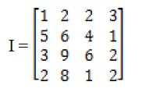

Using 1D HT along first row, the approximation coefficients are

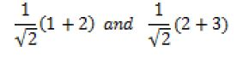

and the detail coefficient are

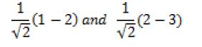

The same transform is applied to the other rows of *I.* By arranging the approximation parts of each row transform in the first two columns and the corresponding detail parts in the last two columns we get the following results:

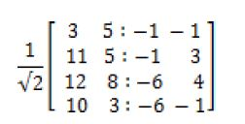

in which approximation and detail parts are separated by dots in each row. By applying the following step of 1D HT to the columns of the resultant matrix, we find that the resultant matrix at first level is

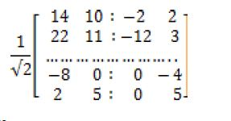

Thus we have

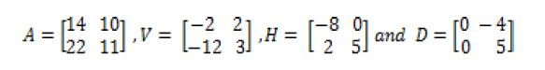

Each piece shown in example has a dimension (number of rows/2) × (number of columns/2) and is called *A*, *H*, *V* and *D* respectively. A (approximation area) includes information about the global properties of analyzed image. Removal of spectral coefficients from this area leads to the biggest distortion in original image. H (horizontal area) includes information about the vertical lines hidden in image. Removal of spectral coefficients from this area excludes horizontal details from original image. V (vertical area) contains information about the horizontal lines hidden in image. Removal of spectral coefficients from this area eliminates vertical details from original image. D (diagonal area) embraces information about the diagonal details hidden in image. Removal of spectral coefficients from this area leads to minimum distortions in original image.

**APPENDIX B**

First, a classifier (namely a cascade of boosted classifiers working with haar-like features) is trained with a few hundred sample views of a particular object (i.e., a face or a car), called positive examples, that are scaled to the same size (say, 20x20), and negative examples - arbitrary images of the same size.

After a classifier is trained, it can be applied to a region of interest (of the same size as used during the training) in an input image. The classifier outputs a “1” if the region is likely to show the object (i.e., face/car), and “0” otherwise. To search for the object in the whole image one can move the search window across the image and check every location using the classifier. The classifier is designed so that it can be easily “resized” in order to be able to find the objects of interest at different sizes, which is more efficient than resizing the image itself. So, to find an object of an unknown size in the image the scan procedure should be done several times at different scales.

The word “cascade” in the classifier name means that the resultant classifier consists of several simpler classifiers (stages) that are applied subsequently to a region of interest until at some stage the candidate is rejected or all the stages are passed. The word “boosted” means that the classifiers at every stage of the cascade are complex themselves and they are built out of basic classifiers using one of four different boosting techniques (weighted voting). Currently Discrete Adaboost, Real Adaboost, Gentle Adaboost and Logitboost are supported. The basic classifiers are decision-tree classifiers with at least 2 leaves. Haar-like features are the input to the basic classifiers, and are calculated as described below. The current algorithm uses the following Haar-like features:

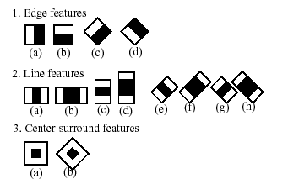

The feature used in a particular classifier is specified by its shape (1a, 2b etc.), position within the region of interest and the scale (this scale is not the same as the scale used at the detection stage, though these two scales are multiplied). For example, in the case of the third line feature (2c) the response is calculated as the difference between the sum of image pixels under the rectangle covering the whole feature (including the two white stripes and the black stripe in the middle) and the sum of the image pixels under the black stripe multiplied by 3 in order to compensate for the differences in the size of areas. The sums of pixel values over a rectangular regions are calculated rapidly using integral images .

But among all these features we calculated, most of them are irrelevant. For example, consider the image below. Top row shows two good features. The first feature selected seems to focus on the property that the region of the eyes is often darker than the region of the nose and cheeks. The second feature selected relies on the property that the eyes are darker than the bridge of the nose. But the same windows applying on cheeks or any other place is irrelevant. So how do we select the best features out of 160000+ features? It is achieved by **Adaboost**.

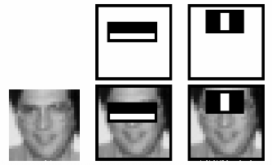

For this, we apply each and every feature on all the training images. For each feature, it finds the best threshold which will classify the faces to positive and negative. But obviously, there will be errors or misclassifications. We select the features with minimum error rate, which means they are the features that best classifies the face and non-face images. (The process is not as simple as this. Each image is given an equal weight in the beginning. After each classification, weights of misclassified images are increased. Then again same process is done. New error rates are calculated. Also new weights. The process is continued until required accuracy or error rate is achieved or required number of features are found).

**JOURNAL PUBLICATIONS**

1. **Sahla Nazlin A** and **Vishnu K**(2017),” Secured Photo Uploading on Online Social Netw-

orks”"International Journal of Innovative Research in Science and Technology(IJIRSET), ISSN:2319-8753,Volume 6 Issue 3, March.(Published)

**2. Sahla Nazlin A** and **Vishnu K**(2017),” Secured Group Photo Uploading on Online Social Networks”"International Journal of Science and research(IJSR) ,ISSN:2321-7782,Volume 4 Issue 6, March.(Published)

3.”Secured Group Photo Uploading on Online Social Networks," II National Conference in Computational Intelligence & Image Processing(RCIP-2017),Calicut(TEQIP II),February 22nd 2017 (Presented)

**CONTROL OF PHOTO SHARING ON ONLINE SOCIAL NETWORKS**

A PROJECT REPORT

Submitted by

**SAHLA NAZLIN A**

**CCV15CSCE13**

**to**

the APJ Abdul Kalam Technological University

in partial fulfillment of the requirements for the award of the Degree

Of

Master of Technology

In

*Computer Science and Engineering*



**Department of Computer Science and Engineering**

Cochin College of Engineering and Technology

Valanchery

MAY 2017

**DECLARATION**

I undersigned hereby declare that the project report “Control of photo sharing on online social network“submitted for partial fulfillment of the requirements for the award of degree of Master of Technology of the APJ Abdul Kalam Technological University, Kerala is a bonafide work done by me under supervision of Mr Vishnu k. This submission represents my ideas in my own words and where ideas or words of others have been included, I have adequately and accurately cited and referenced the original sources. I also declare that I have adhered to ethics of academic honesty and integrity and have not misrepresented or fabricated any data or idea or fact or source in my submission. I understand that any violation of the above will be a cause for disciplinary action by the institute and/or the University and can also evoke penal action from the sources which have thus not been properly cited or from whom proper permission has not been obtained. This report has not been previously formed the basis for the award of any degree, diploma or similar title of any other University.

Place Signature

Date: SahlaNazlinA

**DEPARTMENT OF COMPUTER SCIENCE AND ENGINEERING**

**COCHIN COLLEGE OF ENGINEERING AND TECHNOLOGY,**

**VALANCHERY**



**CERTIFICATE**

This is to certify that the report entitled “**CONTROL OF PHOTOSHARING ON ONLINE SOCIAL NETWORKS”** submitted by **SAHLA NAZLIN A** to the APJ Abdul Kalam Technological University in partial fulfillment of the requirements for the award of the Degree of Master of Technology in Computer Science and Engineering is a bonafide record of the project work carried out by him/her under my/our guidance and supervision.. This report in any form has not been submitted to any other University or Institute for any purpose.

Internal Supervisor(s) External upervisor(s)

(if any)

PG Coordinator Head of the Department

**CONTENTS**

Contents Page No.

ACKNOWLEDGEMENT i

ABSTRACT ii

LIST OF TABLES iii

LIST OF FIGURES iv

ABBREVIATIONS v

NOTATIONS vi

Chapter 1. INTRODUCTION

1.1 General Background

1.2 Objective

1.3 Scheme

Chapter 2. LITERATURE SURVEY

2.1 Privacy Attacks in Social Media Using Photo Tagging Networks: A

Case Study with Facebook.

2.2 Multi-Party Privacy Risks In Social Networks.

2.3 Face Recognition for Improved Face Annotation In Personal

Photo Collection Shared On Online Social Networks.

2.4 Color and Texture Features for Content Based Image Retrieval

2.5 Semantic Image Retrieval by Combining Color, Texture And Shape

Features.

2.6 CBIR Based Image Retrieval Using Modified Haar Wavelet

Transform and K Means Clustering

Chapter 3. PROBLEM DEFINITION

Chapter 4. METHODOLOGY

Chapter 5. TASK AND IMPLEMENTATION

Chapter 6. RESULT AND DISCUSSION

Chapter 7.CONCLUSION AND FUTURE ENHANCEMENT

**ABBRIVIATIONS**

|  |  |  |
| --- | --- | --- |
| **Symbol**  OSNs | **Description**  Online Social Networks | **Page. No**  1 |
| FR | Facial Recognition System | 2 |
| SMS | Short Message Service | 6 |
| CBIR | Content Based Image Retrieval | 8 |
| OPEN CV | Open Source Computer Vision | 8 |
| IDE | Integrated development environment | 10 |
| SD | Standard Deviation | 10 |
| RGB | Red Green Blue | 11 |
| HWT | Haar Wavelength Transformation | 12 |
| DLL | Dynamic Link Library | 13 |
| RAM | Random Access Memory | 16 |
| SVGA | Super Video Graphics Array | 16 |

**NOTATIONS**

|  |  |
| --- | --- |
| I | Image |
| ***U*** | User |
| ***Pu(i)*** | Privacy policy |
| ***Eu(i)*** | Exposure policy |
| ***µ*** | Mean |
| ***w()*** | Weight function |
| ***sim()*** | Similarity function |
| **Eqi** | Euclidean distance |
| ***F*** | Feature vector |
| ***fq*** | Query image feature vector |
| ***fi*** | Input image feature vector |
| Σ | Standard deviation |
| σ **2** | variance |
| **F** | F-norm |
| *Avg* | Average |
| *Diff* | Difference |

**LIST OF TABLES**

|  |  |  |
| --- | --- | --- |
| No | Title | Page No. |
| 6.2.1 | Software Requirement | 45 |
| 6.2.2 | Hardware Requirement | 46 |

**LIST OF FIGURES**

|  |  |  |
| --- | --- | --- |
| No | Title | Page No. |
| 2.6.1 | Architecture of CBIR system |  |
| 4.1 | Proposed System Architecture |  |
| 4.4 | Use case diagram of User |  |
| 4.5 | Collaborative diagram of User |  |
| 4.6 | Use case diagram of Admin |  |
| 4.7 | Collaborative diagram of Admin |  |
| 7.1 | User registration |  |
| 7.2 | User log in |  |
| 7.3 | Upload image for training |  |
| .7.4 | Admin train the image |  |
| 7.5 | Invite friends |  |
| 7.6 | View friend request |  |
| 7.7 | Friend list |  |
| 7.8 | Face Detection |  |
| 7.9 | Acceptance Notification |  |
| 7.10 | Photo posted on time line |  |
| 7.3.1 | Performance analysis |  |

**ACKNOWLEDGEMENT**

First of all we wish to thank God Almighty for His blessings that made our work a success. We are grateful to Mr Zakariya, Principal, Cochin College of Engineering and Technology, Valanchery, for providing the right ambience to do this project.

We would like to extend our sincere gratitude to **Ms. Shyni, , Head of the Computer Science and Engineering Department, Cochin College of Engineering and Technology, Valanchery**, for permitting me to work on the main project and for her guidance, encouragement, support and care throughout the entire period of our course of study. I am deeply indebted to our project coordinator **Ms. Ambili. K** for her continued support throughout our project.

It is with great pleasure that I express my deep sense of gratitude to my project guide **Mr.Vishnu K, Assistant Professor, Department of Computer Science and Engineering, Cochin College of Engineering, Valanchery** for her guidance, supervision, encouragement and valuable advice in each and every phase of my project.

**Date : Sahla Nazlin A**

**ABSTRACT**

Online Social Networks (ONS) have become integral part of our daily life. Photo sharing is one of the most important features of Online Social Networks... Unfortunately which may be used for purposes we never expect. To prevent possible privacy leakage of a group photo, we design a mechanism in which each individual can participate in the decision making on the photo posting. . For this purpose, we need an efficient facial recognition (FR) system that cans recognize everyone in the photo. We are using Haar cascade classifier for face detection and CBIR (content based image retrieval) algorithm to train individual’s images and for face recognition. To get enough training sample is actually little difficult task, so FR engine may be unsuccessful to identify the faces of each individual in a group photo. To avoid this we are using an efficient CBIR algorithm. Once the faces are identified from the group photo then acceptance notifications are sending automatically to each identified persons within the close friend circle. The photo will be posted if all the people within the friend circle are accepting the notification; the photo will not be posted if any one of them rejects the notification. We expect that our proposed scheme would be very useful in protecting users’ privacy in photo/image sharing over online social networks.